**Design Proposal**

**Project Description**

Name: Zhao Peng You (ZPY), English Name: Finding Friends

ZPY is a multiplayer card game where users can play this strategic Chinese Trick Taking game. The card game is similar to Hearts, but with an emphasis on secrecy and creating allies between the “Dictator” team and the “Rebel” team.

**Competitive Analysis**

Seeing that the game is very complex and a little obscure, there is no online version of the game. However, there are online and mobile card games similar to ZPY, like Hearts and Euchre. These games share the trick taking aspect of ZPY, but do not have the same complexity in terms of forming teams and earning points. The Chinese family of trick-taking card games is called *Sheng Ji*, with ZPY being a variant of these card games. There are some projects of online *Sheng Ji,* specifically the variant called “Tractor” or “Tuo La Ji”. My project will be similar in that base rules for ZPY and *Sheng Ji* games are similar. However, there are still rule differences between the games. In addition, the few online *Sheng Ji* games use JavaScript and React, whereas I will be using Python. In addition, my game will be multiplayer, allowing users to play with their friends online, whereas games online are typically against random opponents or a computer.

**Structural Plan**

Card Class:

* Attributes
  + Suit: [Heart, Spade, Diamond, Club]
  + Rank: [A, 2, 3, 4, 5, 6, 7, 8, 9, 10, J, Q, K, Joker]
  + isTrumpNum: Boolean
  + isTrumpSuit: Boolean
* ­isValid(firstSuit)
  + Determines based off first suit, whether a card can be played

Hand Class:

* Attributes
  + Array of Cards called deck, distributed evenly among players
* Add
  + Add card to deck
* Play Card
  + Remove from Hand if isValid
  + Returns the Card
* (Inherited from Hand Class) Dictator Hand Class:
  + Specific attribute: Pot in the middle
  + Swap Cards
    - Switches two cards from Hand and Pot in the Middle

Player Class:

* Attributes
  + Has Hand
  + isDictator
  + isAlly

Game Play:

* Main Screen
  + Control center: directs start, help, and options screen
* Help Screen
  + Visual of Rules
* Options Screen
  + Specific Options, music, number of players
* Dealing Cards Screen
  + Deal Cards:
    - Randomly generates card from array of cards left
    - Adds card to player hand
    - If Trump Number if pulled, stop
  + Deal Cards is called in Timer Fired, card dealt every second
* Choose Allies
  + For dictator, options to choose dictator
* Game Play Screen
  + determineTurn
    - Determines turn
    - If start of round, goes off winner of previous round (or dictator if first round)
    - Goes in clockwise order, stops when all of players have gone
  + whoWon(array of card played)
    - Calculates who won
    - If there are point cards (5, 10, K), adds to the player’s score if isAlly returns False
    - Let’s winner start (determine Turn)
  + allyCardPlayed
    - checks if ally cards are played if allies have revealed themselves
  + endGame
    - Checks if game is over: no card left in hand or opposition has reached set number of points

**Algorithmic Plan**

Approaching the Code for Each Round of the Game:

1. Keep track of cards played in Array of Cards
2. First Turn:
   1. startTurn = person won won last round/dictator for first round
   2. Keep track of first suit to follow
   3. call determineTurn to get the startTurn
3. For the people who it’s not their turn:
   1. Display Waiting textbox
4. For the person who’s turn it is
   1. Allow to use arrow keys to look at cards, click Enter to choose a card
   2. Check if the card is a valid play (isValid) based off the suit of first round
   3. Draw Card in Center after played
5. After Everyone has played
   1. Call WhoWon()
   2. Return Player who Won, number of points
   3. Add points to the player’s score count if player is not an ally/dictator

**Timeline Plan**

* Card Class and Hand Class: **By TP1 (By 11/20)**
* Screen Control: **By TP1 (By 11/20)**
  + Options Screen
  + Help Screen
  + Game play Screen
* Multiplayer Component: **By TP1 (By 11/20)**
  + Syncing so it works on multiple computers
* Basic Rounds: **By 11/22**
  + Dealing Cards
  + Round to Round Play, determining who wins
* Determining Trump: **By 11/24**
  + Beginning of dealing out cards
  + Determining Trump Suit and
* Dictator Component: **By 11/25**
  + Choosing Allies
  + When Allies Reveal Themselves
  + Scoring
* End Game: **By 11/26**
  + Determining who wins
  + Rank moving up for a player after win
* Extra Stuff: **By TP3**
  + AI
  + Change Number of Players
  + Music

**Version Control Plan**

I have a GitHub repository where I will push all my files to.

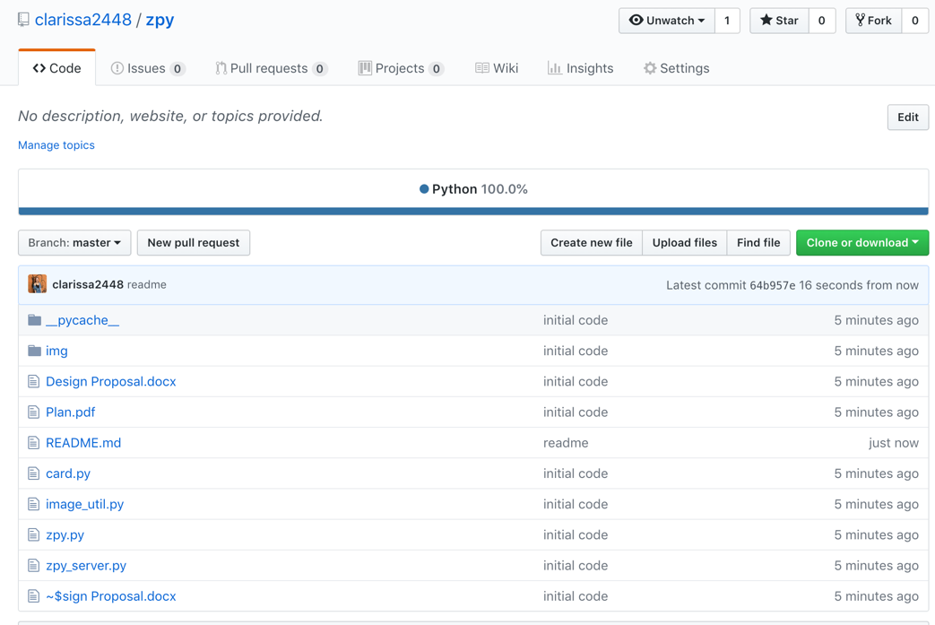

**Module List**

* Sockets/Servers